**\*** 为什么session也要持久化？  
 **\*** 应用保活：重启应用，用户无感知，可以继续以原先的状态继续访问  
 如果不做session持久化，假如一个已经登录的用户正在做新增操作，在还没有提交之前，后台服务器进行了重启，然后用户  
 编辑完数据进行提交，这时服务器因为重启，之前的session丢失，后台检测到用户成了未登录状态，就跳转到用户登录页面，  
 这样的用户体验很不友好，因此session需要进行持久化

测试步骤：

1. 用户登录，进行查询操作

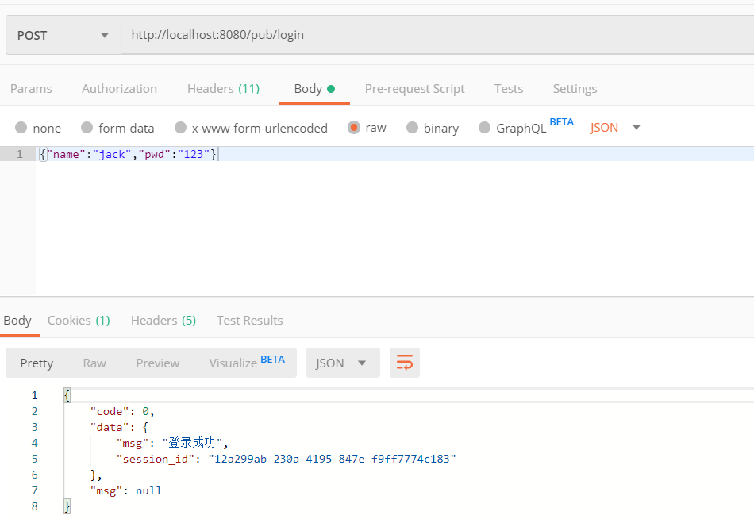

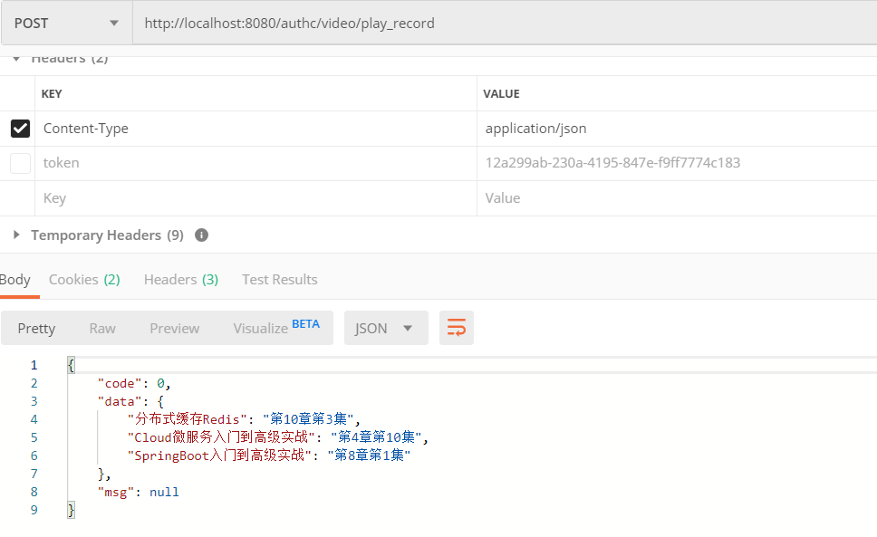

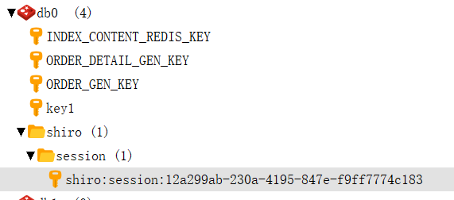

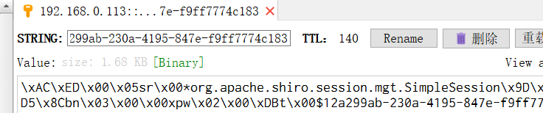

再次查询该接口后,可以看到这个session的缓存时间进行了更新，默认值大概是200s

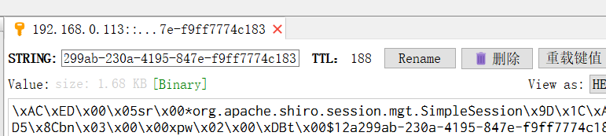

这是因为session的过期时间设置的是200s，当SessionDao没有单独设置过期时间时，默认使用了session的过期时间。

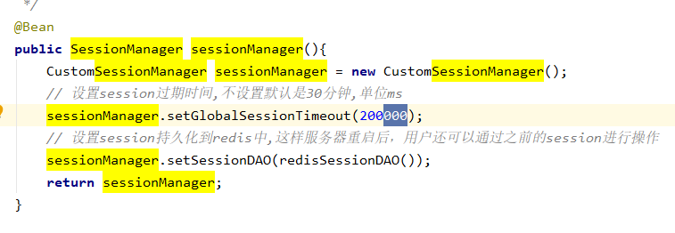

可以在RedisSessionDAO的源码中得到验证：

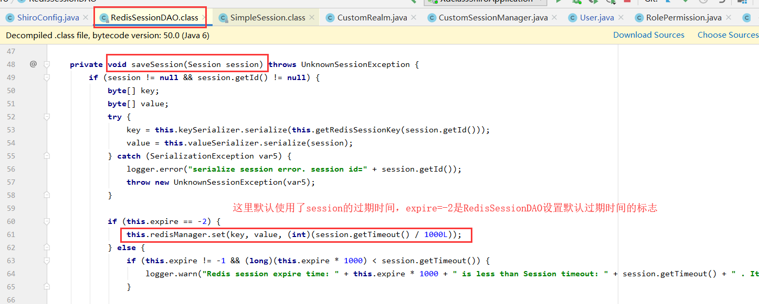

1. 后台服务器重启

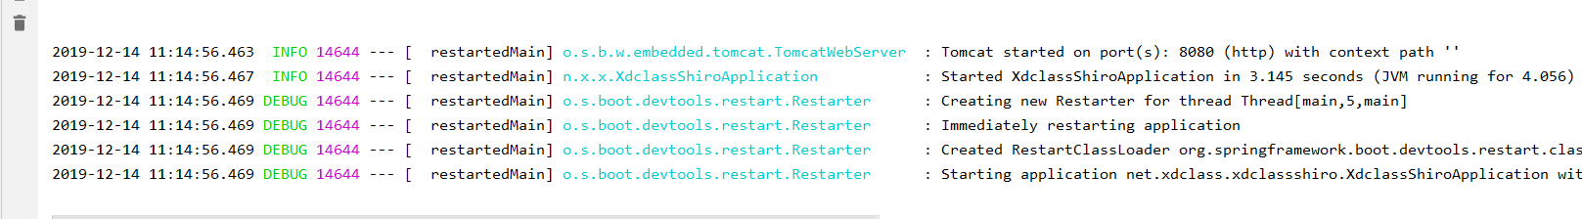

1. 继续使用之前的session进行查询，如果查询成功，说明session持久化生效了

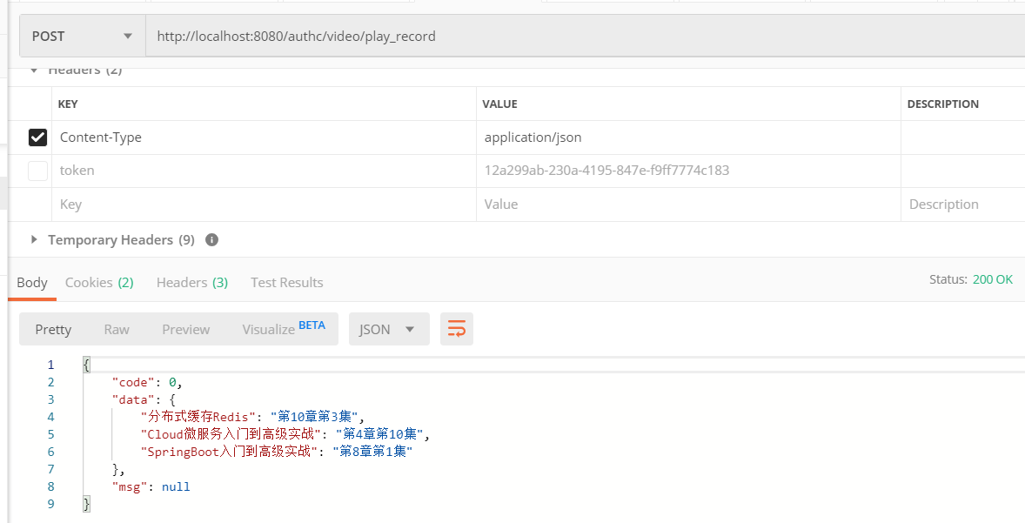

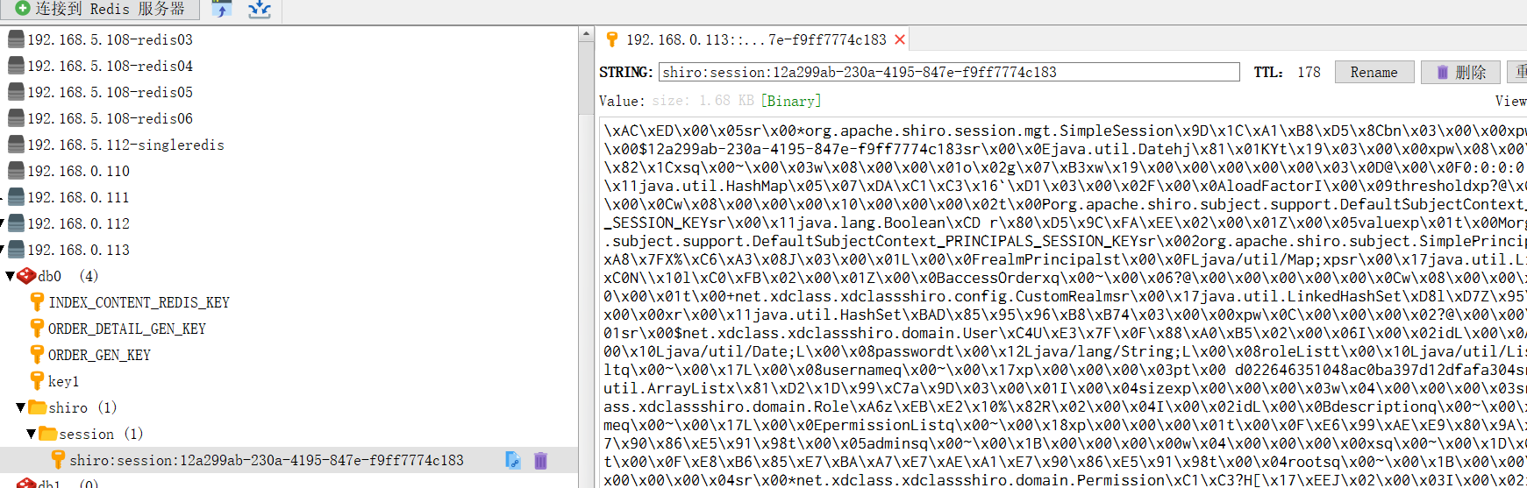

1. 设置redisSessionDAO的过期时间

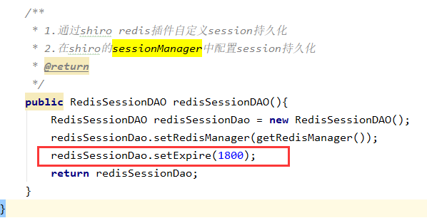

然后重启应用，查看session缓存过期时间，如下：

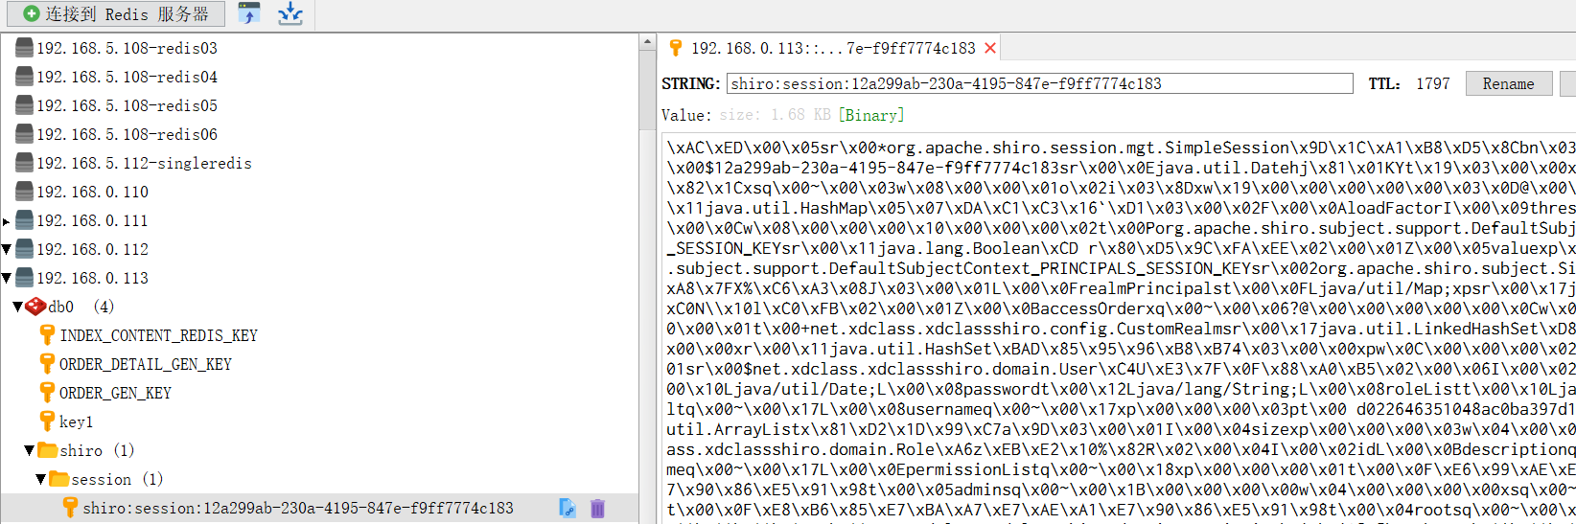

1. 需要注意的地方：DO对象需要实现序列化接口，否则登录的时候会报如下错误：

|  |
| --- |
| 2019-12-14 12:06:35.033 ERROR 10056 --- [nio-8080-exec-2] **org.crazycake.shiro.RedisSessionDAO : serialize session error. session id=3dee1e2d-98fc-49fb-bb1b-a76d1e72e89a**  org.apache.shiro.session.UnknownSessionException: org.crazycake.shiro.exception.SerializationException: serialize error, object=org.apache.shiro.session.mgt.SimpleSession,id=3dee1e2d-98fc-49fb-bb1b-a76d1e72e89a  at org.crazycake.shiro.RedisSessionDAO.saveSession(RedisSessionDAO.java:70)  at org.crazycake.shiro.RedisSessionDAO.update(RedisSessionDAO.java:50)  at org.apache.shiro.session.mgt.DefaultSessionManager.onChange(DefaultSessionManager.java:212)  at org.apache.shiro.session.mgt.AbstractNativeSessionManager.setAttribute(AbstractNativeSessionManager.java:258)  at org.apache.shiro.session.mgt.DelegatingSession.setAttribute(DelegatingSession.java:151)  at org.apache.shiro.session.ProxiedSession.setAttribute(ProxiedSession.java:128)  at org.apache.shiro.mgt.DefaultSubjectDAO.mergePrincipals(DefaultSubjectDAO.java:208)  at org.apache.shiro.mgt.DefaultSubjectDAO.saveToSession(DefaultSubjectDAO.java:165)  at org.apache.shiro.mgt.DefaultSubjectDAO.save(DefaultSubjectDAO.java:146)  at org.apache.shiro.mgt.DefaultSecurityManager.save(DefaultSecurityManager.java:387)  at org.apache.shiro.mgt.DefaultSecurityManager.createSubject(DefaultSecurityManager.java:354)  at org.apache.shiro.mgt.DefaultSecurityManager.createSubject(DefaultSecurityManager.java:187)  **at org.apache.shiro.mgt.DefaultSecurityManager.login(DefaultSecurityManager.java:287)**  at org.apache.shiro.subject.support.DelegatingSubject.login(DelegatingSubject.java:260)  **at net.xdclass.xdclassshiro.controller.PublicController.login(PublicController.java:72)**  at sun.reflect.NativeMethodAccessorImpl.invoke0(Native Method)  at sun.reflect.NativeMethodAccessorImpl.invoke(NativeMethodAccessorImpl.java:62)  at sun.reflect.DelegatingMethodAccessorImpl.invoke(DelegatingMethodAccessorImpl.java:43)  at java.lang.reflect.Method.invoke(Method.java:498)  at org.springframework.web.method.support.InvocableHandlerMethod.doInvoke(InvocableHandlerMethod.java:190)  at org.springframework.web.method.support.InvocableHandlerMethod.invokeForRequest(InvocableHandlerMethod.java:138)  at org.springframework.web.servlet.mvc.method.annotation.ServletInvocableHandlerMethod.invokeAndHandle(ServletInvocableHandlerMethod.java:106)  at org.springframework.web.servlet.mvc.method.annotation.RequestMappingHandlerAdapter.invokeHandlerMethod(RequestMappingHandlerAdapter.java:888)  at org.springframework.web.servlet.mvc.method.annotation.RequestMappingHandlerAdapter.handleInternal(RequestMappingHandlerAdapter.java:793)  at org.springframework.web.servlet.mvc.method.AbstractHandlerMethodAdapter.handle(AbstractHandlerMethodAdapter.java:87)  at org.springframework.web.servlet.DispatcherServlet.doDispatch(DispatcherServlet.java:1040)  at org.springframework.web.servlet.DispatcherServlet.doService(DispatcherServlet.java:943)  at org.springframework.web.servlet.FrameworkServlet.processRequest(FrameworkServlet.java:1006)  at org.springframework.web.servlet.FrameworkServlet.doPost(FrameworkServlet.java:909)  at javax.servlet.http.HttpServlet.service(HttpServlet.java:660)  at org.springframework.web.servlet.FrameworkServlet.service(FrameworkServlet.java:883)  at javax.servlet.http.HttpServlet.service(HttpServlet.java:741)  at org.apache.catalina.core.ApplicationFilterChain.internalDoFilter(ApplicationFilterChain.java:231)  at org.apache.catalina.core.ApplicationFilterChain.doFilter(ApplicationFilterChain.java:166)  at org.apache.tomcat.websocket.server.WsFilter.doFilter(WsFilter.java:53)  at org.apache.catalina.core.ApplicationFilterChain.internalDoFilter(ApplicationFilterChain.java:193)  at org.apache.catalina.core.ApplicationFilterChain.doFilter(ApplicationFilterChain.java:166)  at org.apache.shiro.web.servlet.ProxiedFilterChain.doFilter(ProxiedFilterChain.java:61)  at org.apache.shiro.web.servlet.AdviceFilter.executeChain(AdviceFilter.java:108)  at org.apache.shiro.web.servlet.AdviceFilter.doFilterInternal(AdviceFilter.java:137)  at org.apache.shiro.web.servlet.OncePerRequestFilter.doFilter(OncePerRequestFilter.java:125)  at org.apache.shiro.web.servlet.ProxiedFilterChain.doFilter(ProxiedFilterChain.java:66)  at org.apache.shiro.web.servlet.AbstractShiroFilter.executeChain(AbstractShiroFilter.java:449)  at org.apache.shiro.web.servlet.AbstractShiroFilter$1.call(AbstractShiroFilter.java:365)  at org.apache.shiro.subject.support.SubjectCallable.doCall(SubjectCallable.java:90)  at org.apache.shiro.subject.support.SubjectCallable.call(SubjectCallable.java:83)  at org.apache.shiro.subject.support.DelegatingSubject.execute(DelegatingSubject.java:387)  at org.apache.shiro.web.servlet.AbstractShiroFilter.doFilterInternal(AbstractShiroFilter.java:362)  at org.apache.shiro.web.servlet.OncePerRequestFilter.doFilter(OncePerRequestFilter.java:125)  at org.apache.catalina.core.ApplicationFilterChain.internalDoFilter(ApplicationFilterChain.java:193)  at org.apache.catalina.core.ApplicationFilterChain.doFilter(ApplicationFilterChain.java:166)  at org.springframework.web.filter.RequestContextFilter.doFilterInternal(RequestContextFilter.java:100)  at org.springframework.web.filter.OncePerRequestFilter.doFilter(OncePerRequestFilter.java:119)  at org.apache.catalina.core.ApplicationFilterChain.internalDoFilter(ApplicationFilterChain.java:193)  at org.apache.catalina.core.ApplicationFilterChain.doFilter(ApplicationFilterChain.java:166)  at org.springframework.web.filter.FormContentFilter.doFilterInternal(FormContentFilter.java:93)  at org.springframework.web.filter.OncePerRequestFilter.doFilter(OncePerRequestFilter.java:119)  at org.apache.catalina.core.ApplicationFilterChain.internalDoFilter(ApplicationFilterChain.java:193)  at org.apache.catalina.core.ApplicationFilterChain.doFilter(ApplicationFilterChain.java:166)  at org.springframework.web.filter.CharacterEncodingFilter.doFilterInternal(CharacterEncodingFilter.java:201)  at org.springframework.web.filter.OncePerRequestFilter.doFilter(OncePerRequestFilter.java:119)  at org.apache.catalina.core.ApplicationFilterChain.internalDoFilter(ApplicationFilterChain.java:193)  at org.apache.catalina.core.ApplicationFilterChain.doFilter(ApplicationFilterChain.java:166)  at org.apache.catalina.core.StandardWrapperValve.invoke(StandardWrapperValve.java:202)  at org.apache.catalina.core.StandardContextValve.invoke(StandardContextValve.java:96)  at org.apache.catalina.authenticator.AuthenticatorBase.invoke(AuthenticatorBase.java:526)  at org.apache.catalina.core.StandardHostValve.invoke(StandardHostValve.java:139)  at org.apache.catalina.valves.ErrorReportValve.invoke(ErrorReportValve.java:92)  at org.apache.catalina.core.StandardEngineValve.invoke(StandardEngineValve.java:74)  at org.apache.catalina.connector.CoyoteAdapter.service(CoyoteAdapter.java:343)  at org.apache.coyote.http11.Http11Processor.service(Http11Processor.java:408)  at org.apache.coyote.AbstractProcessorLight.process(AbstractProcessorLight.java:66)  at org.apache.coyote.AbstractProtocol$ConnectionHandler.process(AbstractProtocol.java:861)  at org.apache.tomcat.util.net.NioEndpoint$SocketProcessor.doRun(NioEndpoint.java:1579)  at org.apache.tomcat.util.net.SocketProcessorBase.run(SocketProcessorBase.java:49)  at java.util.concurrent.ThreadPoolExecutor.runWorker(ThreadPoolExecutor.java:1149)  at java.util.concurrent.ThreadPoolExecutor$Worker.run(ThreadPoolExecutor.java:624)  at org.apache.tomcat.util.threads.TaskThread$WrappingRunnable.run(TaskThread.java:61)  at java.lang.Thread.run(Thread.java:748)  Caused by: org.crazycake.shiro.exception.SerializationException: serialize error, object=org.apache.shiro.session.mgt.SimpleSession,id=3dee1e2d-98fc-49fb-bb1b-a76d1e72e89a  at org.crazycake.shiro.serializer.ObjectSerializer.serialize(ObjectSerializer.java:32)  at org.crazycake.shiro.RedisSessionDAO.saveSession(RedisSessionDAO.java:67)  ... 78 more  Caused by: java.io.NotSerializableException: net.xdclass.xdclassshiro.domain.User  at java.io.ObjectOutputStream.writeObject0(ObjectOutputStream.java:1184)  at java.io.ObjectOutputStream.writeObject(ObjectOutputStream.java:348)  at java.util.HashSet.writeObject(HashSet.java:288)  at sun.reflect.NativeMethodAccessorImpl.invoke0(Native Method)  at sun.reflect.NativeMethodAccessorImpl.invoke(NativeMethodAccessorImpl.java:62)  at sun.reflect.DelegatingMethodAccessorImpl.invoke(DelegatingMethodAccessorImpl.java:43)  at java.lang.reflect.Method.invoke(Method.java:498)  at java.io.ObjectStreamClass.invokeWriteObject(ObjectStreamClass.java:1140)  at java.io.ObjectOutputStream.writeSerialData(ObjectOutputStream.java:1496)  at java.io.ObjectOutputStream.writeOrdinaryObject(ObjectOutputStream.java:1432)  at java.io.ObjectOutputStream.writeObject0(ObjectOutputStream.java:1178)  at java.io.ObjectOutputStream.writeObject(ObjectOutputStream.java:348)  at java.util.LinkedHashMap.internalWriteEntries(LinkedHashMap.java:333)  at java.util.HashMap.writeObject(HashMap.java:1363)  at sun.reflect.NativeMethodAccessorImpl.invoke0(Native Method)  at sun.reflect.NativeMethodAccessorImpl.invoke(NativeMethodAccessorImpl.java:62)  at sun.reflect.DelegatingMethodAccessorImpl.invoke(DelegatingMethodAccessorImpl.java:43)  at java.lang.reflect.Method.invoke(Method.java:498)  at java.io.ObjectStreamClass.invokeWriteObject(ObjectStreamClass.java:1140)  at java.io.ObjectOutputStream.writeSerialData(ObjectOutputStream.java:1496)  at java.io.ObjectOutputStream.writeOrdinaryObject(ObjectOutputStream.java:1432)  at java.io.ObjectOutputStream.writeObject0(ObjectOutputStream.java:1178)  at java.io.ObjectOutputStream.defaultWriteFields(ObjectOutputStream.java:1548)  at java.io.ObjectOutputStream.defaultWriteObject(ObjectOutputStream.java:441)  at org.apache.shiro.subject.SimplePrincipalCollection.writeObject(SimplePrincipalCollection.java:274)  at sun.reflect.NativeMethodAccessorImpl.invoke0(Native Method)  at sun.reflect.NativeMethodAccessorImpl.invoke(NativeMethodAccessorImpl.java:62)  at sun.reflect.DelegatingMethodAccessorImpl.invoke(DelegatingMethodAccessorImpl.java:43)  at java.lang.reflect.Method.invoke(Method.java:498)  at java.io.ObjectStreamClass.invokeWriteObject(ObjectStreamClass.java:1140)  at java.io.ObjectOutputStream.writeSerialData(ObjectOutputStream.java:1496)  at java.io.ObjectOutputStream.writeOrdinaryObject(ObjectOutputStream.java:1432)  at java.io.ObjectOutputStream.writeObject0(ObjectOutputStream.java:1178)  at java.io.ObjectOutputStream.writeObject(ObjectOutputStream.java:348)  at java.util.HashMap.internalWriteEntries(HashMap.java:1790)  at java.util.HashMap.writeObject(HashMap.java:1363)  at sun.reflect.NativeMethodAccessorImpl.invoke0(Native Method)  at sun.reflect.NativeMethodAccessorImpl.invoke(NativeMethodAccessorImpl.java:62)  at sun.reflect.DelegatingMethodAccessorImpl.invoke(DelegatingMethodAccessorImpl.java:43)  at java.lang.reflect.Method.invoke(Method.java:498)  at java.io.ObjectStreamClass.invokeWriteObject(ObjectStreamClass.java:1140)  at java.io.ObjectOutputStream.writeSerialData(ObjectOutputStream.java:1496)  at java.io.ObjectOutputStream.writeOrdinaryObject(ObjectOutputStream.java:1432)  at java.io.ObjectOutputStream.writeObject0(ObjectOutputStream.java:1178)  at java.io.ObjectOutputStream.writeObject(ObjectOutputStream.java:348)  at org.apache.shiro.session.mgt.SimpleSession.writeObject(SimpleSession.java:461)  at sun.reflect.NativeMethodAccessorImpl.invoke0(Native Method)  at sun.reflect.NativeMethodAccessorImpl.invoke(NativeMethodAccessorImpl.java:62)  at sun.reflect.DelegatingMethodAccessorImpl.invoke(DelegatingMethodAccessorImpl.java:43)  at java.lang.reflect.Method.invoke(Method.java:498)  at java.io.ObjectStreamClass.invokeWriteObject(ObjectStreamClass.java:1140)  at java.io.ObjectOutputStream.writeSerialData(ObjectOutputStream.java:1496)  at java.io.ObjectOutputStream.writeOrdinaryObject(ObjectOutputStream.java:1432)  at java.io.ObjectOutputStream.writeObject0(ObjectOutputStream.java:1178)  at java.io.ObjectOutputStream.writeObject(ObjectOutputStream.java:348)  at org.crazycake.shiro.serializer.ObjectSerializer.serialize(ObjectSerializer.java:28)  ... 79 more  2019-12-14 12:06:35.063 DEBUG 10056 --- [nio-8080-exec-2] m.m.a.RequestResponseBodyMethodProcessor : Using 'application/json', given [*/*] and supported [application/json, application/*+json, application/json, application/*+json]  2019-12-14 12:06:35.064 DEBUG 10056 --- [nio-8080-exec-2] m.m.a.RequestResponseBodyMethodProcessor : Writing [JsonData [code=-1, data=null, msg=登录失败]]  2019-12-14 12:06:35.080 DEBUG 10056 --- [nio-8080-exec-2] o.s.web.servlet.DispatcherServlet : Completed 200 OK |

为什么session持久化需要DO实现序列化接口呢？可以查看上面错误日志中的代码调用链，可以看到.RedisSessionDAO.saveSession的方法，最终会使用到 **net.xdclass.xdclassshiro.controller.PublicController.login(PublicController.java:72)**

**方法，这个登录方法72行代码内容如下：**

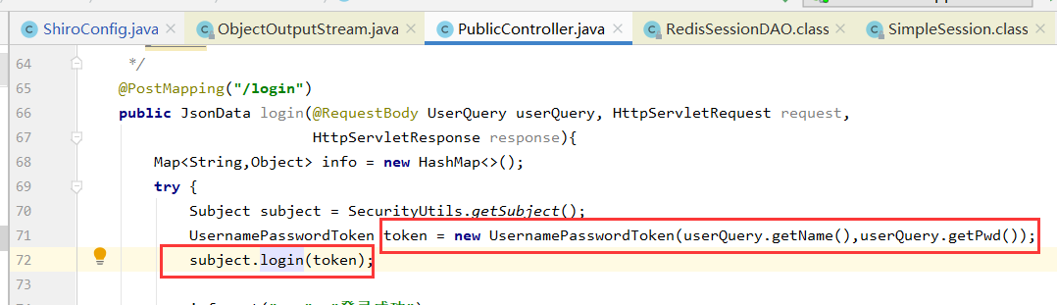

这是因为login方法使用了token,token的生成用到了User的信息，因此User需要实现序列化，User对象里面所引用的对象也需要实现序列化接口